UNH SEDS Leadership

# The Purpose of UNH SEDS

UNH SEDS is part of a nation-wide organization dedicated to educating students about space exploration and development. UNH SEDS designs and manufactures many engineering projects every year with the goal to give all its members a well-rounded experience, no matter the major. Although engineering is the primary reason people join the club, it isn’t its true purpose. Fundamentally, it is for connections. UNH isn’t rooted in space, and many students struggle to find the experience and connections needed to join the industry. UNH SEDS was created to give both of those by allowing students to work as a team, network at events, watch speakers, and of course, participate in engineering projects. As UNH SEDS grows to the largest engineering organization, remember the true purpose: connections.

# The Board

During UNH SEDS’ conception, there was really one (or two) roles of leadership, the President and Vice President. As we have expanded, that was no longer sustainable. As a club grows, so does the growing responsibilities to run it. The following positions were created to provide a backbone of leadership that enables a sustainable, strong student force running the organization.

1. President
2. Vice President
3. Treasurer
4. Member at Large
5. Safety Officer
6. Lead Engineer

These positions were created to disperse the responsibilities of running (and expanding) a student organization and shouldn’t need to be changed until the membership needs make it so (greater than 75 active students). The following document will detail each position, and its true purpose.

# President

The President of UNH SEDS acts as the face of the organization. If the President does not treat this organization as their kid, it will not grow and slowly die. The organization grows as fast as the President’s passion. Remember that.

The primary duties of the President are the least straight forward and most open-ended of the board positions. This is on purpose, as much of what the President does cannot be summed up in text, but just performed. It is imperative that the President understands that this position should make the SEDS shop your ‘home base.’ It should become usual that the President spends as much time in the UNH SEDS shop then they do in their bed (a little bit of an exaggeration, but not really). There is an affect of always having someone in the room, and the President should lead by example and create that ‘home’ community within the SEDS space. It has huge implications on how the university staff perceive you, and they will help you more if they feel a strong presence from your group. The shop has one desk located against the back wall labeled ‘Da President’ and shall remain the President’s private desk. Comes with the job! All other computers are primarily for the other board members and engineering leads. The President doesn’t need to be the most popular person, or outwardly going. Any personality type is able, but they must focus on inspiring potential and current members on the mission of UNH SEDS, and have the greatest passion within the organization.

## The Responsibilities

1. Oversee the direction of the organization to continue traditions as well as expand the reach
   1. This is vague on purpose, as it can’t be defined. Work tirelessly at this bullet point as it is the most important
2. Lead recruitment efforts each semester, and table when asked upon
   1. The designated primary helper for this is the Member at Large. It has been useful to offer pizza during the main recruitment meetings and make them inspiring!
3. Maintain contact with the club advisor and SEDS USA
   1. Todd Gross is the club and engineering advisor, while SEDS USA leadership can always be found at seds.org. Should attend or delegate to another board member to attend the weekly SEDS USA CoC meeting
4. Organize and direct weekly general meetings
   1. It is expected to have an organization agenda, as well as have a workshop/speaker each meeting
5. Manage and assist all board member activities
   1. Maintain communication with the entire board, and check up on projects regularly

# Vice President

The Vice President, in its roots, is the President’s right hand mate. It doesn’t come with the ‘face of the organization’ award, but it is crucial. It is very rare for someone to have the ability to take on a large organization by him/herself, so having a confidant is important. People make mistakes, and getting advice is needed every day when it comes to running an organization. The President and Vice President should have a good working relationship, as well as a personal one. Being friends with the people we work closely with, especially in college, is very important. Grab a beer, take a shot together. Just because we are engineers at heart doesn’t mean getting drunk together is impossible.

The primary duties of the Vice President are more explicit then the President, but if there is ever a time the President must resign, the Vice President should have the same abilities as the President to take on that role. So, as the shop is the President’s home, so it should be for the Vice President. The amount of passion in each the President and Vice President should be the greatest within the organization. These positions are not by ability, but by what your potential is to the club and your outward passion on space.

## The Responsibilities

1. The ability to assume the roles of the President when asked or needed to
   1. This is if the President resigns, needs a period of leave, or dies
2. Assists the President with general meetings and any delegated tasks
   1. The General meetings are becoming larger as each year passes, and an addition leader on this is needed
3. Maintains communication with the UNH Student organization (MUB) staff to maintain organization status and overall relationship with UNH
   1. There is a required all-hands meeting each semester, and some grants come from UNH and the student organization committee.
4. Manages the Treasurer directly and lead the communication with our current partners/sponsors by the weekly newsletter and individual emails/calls
   1. The Vice President/Treasurer team is very important to maintaining and creating new industry/academic connections. Critical to the development of UNH SEDS and obtaining internships/jobs to the members
5. Manages the UNH SEDS Website with the help of one UNH SEDS web developer (non-board position)
   1. Required to keep it up to date with relevant information as it is a great tool to show people what UNH SEDS is all about. Should schedule occasional website meetings

# Treasurer

The Treasurer is the root of our financial power. This position could quadruple our spending power in one year (2019-2020) or decrease overall funding. This position is fairly defined in their basic duties, but much of what comes from a Treasurer is when they think outside the box. Strong leadership and project management skills are needed as help from the entire team (or just a lot of dedication to do it yourself!).

The primary duties of the Treasurer are to raise funds for the group in both its organizational and engineering departments. It is common to have a significant amount of funds go to the annual Spacevision conference, while most of it goes to overall engineering efforts. The amount of expansion and affect UNH SEDS can have is directly proportional to its financial backing. Sponsorship also leads to strong partner relationships that land to internships and jobs for our members. The Treasurer also works very closely with the Vice President to maintain all sponsors and industry partners to allow yearly resurrection of their continued support.

## The Responsibilities

1. Organize and lead finance initiatives throughout the year for organization and engineering use that is sustainable every year
   1. Although the hardest responsibility to get help on, it can be done if done right (live tracking, incentives)
2. Write, submit and manage relationships with all grant applications including but not limited to CEPS, Alumni, Parents, SEDS.
   1. This pulls in a significant amount of money for UNH SEDS each year and should be done very well each year and update the contact throughout the year to maintain a strong relationship.
3. Maintain and foster a strong connection with our financial account advisor and keeping a live financial standing sheet
   1. Within the Business Service Center of Kingsbury 3rd floor, it is very important to nurture a strong relationship to keep our finances in order and a strong relationship with CEPS money
4. Maintain a constant line of communication with our industry and academic connection base via our weekly newsletter and individual email chains
   1. Although the Vice President will manage, the Treasurer is designated as the main lead on this. A good steppingstone to transition to Vice President.

# Member at Large

The hardest thing to learn coming into overall club management is the importance of a strong organization dynamic. It took a full year to secure a spot with Kingsbury, and it has had profound effects to the overall growth of the club. A home is important, right? Although the Member at Large does not need to go through the pain of creating something from scratch, there is a pain in maintaining and improving it. The shop is our strongest asset, and it must be presented to our members, the school and tours that walk by as the most well-managed section in the hall.

The primary duties of the Member at Large are quite broad but centralizes around the members of the organization. Although we have meetings and find our friends within the team, the group dynamic is important and does not come naturally. The primary objective of the Member at Large is to create an environment and manage the events needed to bring us together as friends, and ultimately, a family. The Member at Large is also responsible for directly helping the President when needed with smaller tasks (and prove that they can move up to larger leadership positions later.) A few additions to the room, including the TV and the white boards, are great way to create a better environment and keep the entire team on the same page and should be utilized daily.

## The Responsibilities

1. Facilitate and organize the UNH SEDS shop structure for a welcoming, working environment
   1. Should be a constant process, but initiative should be taken to purchase and create better methods for sustainable shop organization/structure.
2. Work to create a healthy club dynamic and organize club bonding activities (during and outside of meetings)
   1. We are a team, and sometimes events outside of Kingsbury is critically important to keep everyone sane and healthy
3. Manage the use of the TV and shop white boards by staying up to date with club happenings to relay to the team in person, on the boards, and on slack.
   1. The use of these items helps a lot with an active and modern feel in the room and attracts many people to stop by (not to mention tours!)
4. Assist the President when needed (and other board members when available).
   1. Although the Vice President is always there for the President, sometimes tasks are great for the member at large as a training ground for more responsibility later in their UNH SEDS career

# Safety Officer

The Safety Officer is critical to the board as it allows for a leadership position with UNH SEDS dedicated to overall safety. Although everything can be fun and games, the work we do can be dangerous and it is important to keep safety at the forefront of the organization.

The primary duties of the Safety Officer are to create a safe environment for everyone in the shop, and make sure UNH SEDS maintains code through the years to not have infractions from informational transitions in people. It should be made clear that any complaints regarding safety should be reported to the Safety Officer. They work directly with the Lead Engineer.

## The Responsibilities

1. Organize and facilitate the safety procedure and equipment needed for all club operations
   1. This is the main part of the job and should be very active in ensuring all activities are as safe as possible
2. Maintain a healthy and strong connection with the UNH safety official including the police and fire departments, and Environmental Health and Safety
   1. There is a specific fire-resistant section of the room with a fire cabinet, all of which was guide lined by EHS and the fire department. Keep up to date with their leaders and keep them updated on club safety activities.
3. Organize a safety meeting once a year during a general meeting for all members to attend that includes safety officials coming in to meet the team, present on their work and explain why safety is crucial
   1. Helps maintain clear information to the entire club base on why safety is important, and how to prevent safety hazards

# Lead Engineer

The Lead Engineer is responsible for leading all the engineering activities of the organization. Although the mission of the organization can change year-to-year, the Lead Engineer is responsible for creating a strong engineering team that pushes their boundaries and create beautiful systems in the discipline of space exploration. The Lead Engineer should be the most well-rounded team member in engineering and past UNH SEDS engineering activities/projects. It is critical that not only is the Lead Engineer a strong engineering student rooted in fundamentals, they must possess a natural passion for the work as this can easily be the longest hour position within the board, especially as the club activities grow larger in the engineering department.

The primary duties of the Lead Engineer are to ‘lead’. It doesn’t inherently come with the need to know every software and have taken every engineering class. The first Lead Engineer for UNH SEDS was a sophomore. The most important ability is engineering management, and that is the primary duty for the Lead Engineer. Understand who you are working with, their limits, and their imperatives. It can take years to fully understand this, but trial and error is a great teacher. To learn, one must fail, and the Lead Engineer must be quite open to failure, as you WILL see it far more frequently then success.

## The Responsibilities

1. Create and oversee all engineering efforts within the organization with the feedback from club members on what they want to work on
   1. The bulk of the work on the day-to-day. A manager has a different skillset than an individual contributor and is just as important. No task is too menial.
2. Assign, manage and advise all engineering leads
   1. Many engineering leads will come from the senior design class, and are strongly encouraged to be previous members of the club as passion is extremely important for these roles as managers
3. Create and communicate engineering timelines and project management media to help with the communication of what is needed and when
   1. Over-communication doesn’t really exist with students. Make sure people know what is going through your mind and relay key dates and times all the time
4. Lead efforts for engineering succession from year to year.
   1. Essential. Make sure the underclassmen in each class are masters in every engineering project to continue, not start over.

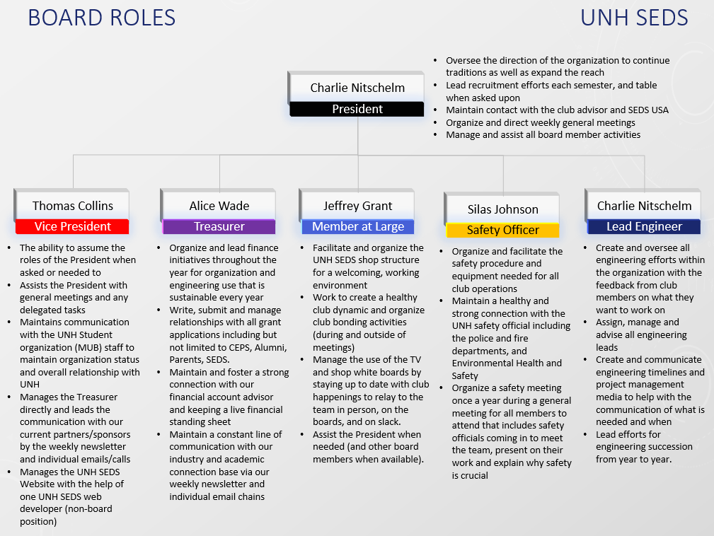

Figure 1- Animation found on Github and should be updated when board changes occur